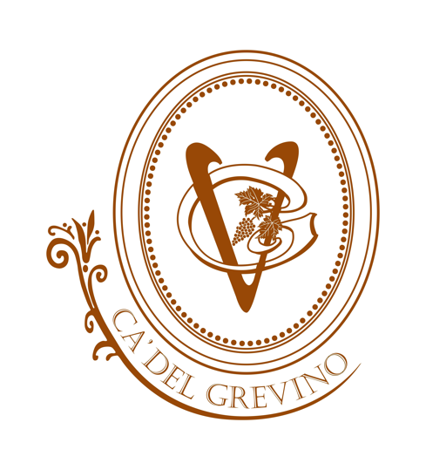

Tasting Room & Cafe
Chef: Jonathan Price
Starters
Chef JP’s Hand Rolled Tacos $4 each – tri-tip, chicken or Thai (shrimp add $1)
Soup Du Jour Bowl $6 /Cup $4- ask for the “daily selection”
Avocado Bomb $9 – filled with shrimp, carrot and scallion in an amazing jalapeño-soy sauce
Baked Brie Crostini $10 –fresh baked in pastry dough, warm with house candied walnuts and honey
Spanish Olives $6 –Spanish olives with olive oil
Marcona Almonds $8 – roasted with truffle oil and sea salt
Seasoned Artichoke Hearts $6 – warm with Parmigiano and Garlic
Steak Bites $12 – Cooked to perfection with cremini mushrooms, carrot-ginger sauce, and micro cilantro

Cheese & Charcuterie Boards
Cheese Board $14 – Parmigiano, Manchego, Blue & Paprika Goat Cheese with fruit and nuts
Meat & Cheese Board $16– Salami, Prosciutto, chef selection of Cheeses, Almonds, Olives, and Artichoke Hearts

Salads $12
The Grevino - mixed greens, mozzarella, red onion, tomatoes, parmesan tossed with pesto and lemon vinaigrette
Caprese - tomato, basil, fresh mozzarella, balsamic reduction and extra virgin olive oil
Mixed Greens - cranberry, walnut, apple, goat cheese, balsamic vinaigrette
Caesar - romaine, parmesan, breadcrumbs , house made caesar dressing
Roasted Beet - tomato, avocado, mixed greens, walnuts, goat cheese, and balsamic reduction
Avocado Bomb Salad - avocado with shrimp, carrots, scallion and jalapeno- soy sauce on a bed of greens
Add Chicken $4 Add Tri-Tip $6

Oven and Grill
French Dip Sliders $15 –thinly sliced tri tip, Swiss cheese, house made au jus
Chicken Piccata $21 – potatoes, green beans, asparagus, capers, butter lemon sauce
Chicken curry $20 – Pineapple, curry, coconut, bamboo shoots, jasmine rice
Salmon $22 – Bell peppers, asparagus, onion, cilantro, lemon butter sauce
The Grevino Burger $16 – Bacon, fried egg, lettuce, tomato, cheddar (with soup or salad)

Flat Bread Pizza’s
Veggie Pesto $13 - Artichoke Hearts, Onion, Red Peppers, olives and mozzarella
Tri-Tip and Blue Cheese $15 -Red sauce, red onion, balsamic reduction, mozzarella and parmesan
Prosciutto and Fig $16 - Avocado, garlic olive oil, mozzarella and Parmigiano
Chicken and Jalapeno $15 - White cheddar sauce, onion, mozzarella
Spicy Thai $15 - Cucumber, tri-tip, sriracha, sesame, mozzarella
Macaroni and Cheese $14 - Macaroni, Cheddar, bacon, jalapeno
BBQ Chicken $15 - Chicken, BBQ sauce, onion, mozzarella, cilantro
Chorizo and Mushroom $15 - Chorizo, mushroom, cilantro sriracha, onion, mozzarella
Calabrese Salami $15 - Red sauce, mozzarella & Parmigiano
Additional Toppings add $1

Tasting Room & Cafe

Grevino Classic Cocktails $9
Margarita- Rancho Alegre blanco, triple sec, lime juice, and sweet & sour
Old Fashioned- Beam 8 bourbon, sugar, fresh squeezed orange, bitters
Moscow Mule- Svedka vodka, lime juice, and ginger beer
The Grevino Godfather- Lauders scotch, amaretto, lemon
Mojito- Cruzan rum, mint, lime juice, simple syrup, and soda water

Martinis $12
Cucumber Apple Martini - Kettle One vodka, muddled cucumber, green apple, and lime
Orange Thyme Martini- Bombay Sapphire gin, fresh thyme, muddled orange, and a splash of tonic water
Maker’s Manhattan- Maker’s Mark Bourbon, sweet vermouth, Angostura bitters, lemon, lime, and orange
Tramonto “Sunset” Martini- Captain Morgan Grapefruit rum, triple sec, pineapple juice, and grenadine
Silver Tequila Martini- Milagro silver tequila, dry vermouth, pink grapefruit juice, and orange bitters
Cosmopolitan- Deep Eddy Ruby Red vodka, triple sec, lime juice, and cranberry juice

Bottled Beer
Cali-Veza
Peroni
805
Sierra Nevada Pale Ale
Lagunitas IPA
Sculpin IPA
Blue Moon
Mo-tra

